**Homework 2** Due October 22, 2021

Cristian Brinza FAF 212

**Problem 2.1**

A die is rolled twice. What is the probability that the sum of the faces is greater than 5 (event *E*), given that

1. the first outcome was a 3?

$$m\left(ω\right)=\frac{1}{6}, E-first outcome was 3→ω-3,4,5,6 P\left(F\right)=\frac{4}{6}=\frac{2}{3}$$

1. the first outcome was greater than 4?
$$m\left(ω\right)=\frac{1}{6}, E-first outcome was greater than 4→5 or 6→ω-1,2,3,4,5,6 P\left(F\right)=\frac{6}{6}=1$$

2. the first outcome was 1?
$$m\left(ω\right)=\frac{1}{6}, E-first outcome was 1→ω-5,6 P\left(F\right)=\frac{2}{6}=\frac{1}{3}$$

3. the first outcome was less than 5?

$$m\left(ω\right)=\frac{1}{6}, E-first outcome was less than 5→1 or 2 or 3 or 4→ω-1,2,3,4,5,6 P\left(F\right)=\frac{7}{12}$$

**Problem 2.2**

There are two urns. In urn *I* there are 5 white balls and 6 black balls, in urn *II* there are 4 white balls and 3 black balls. 2 balls from urn *I* are picked at random and transferred in urn *II*. Then, two balls are chosen at random from urn *II*.

What is the probability that both balls are black?

$$F-Both balls are black P\left(F\right)=\frac{3}{11}⋅\frac{20}{72}+\frac{3}{11}⋅\frac{12}{72}+\frac{2}{11}⋅\frac{6}{72}=\frac{60+36+36+12}{792}=\frac{144}{792}=\frac{2}{11}$$

What is the probability that balls of the same color were transferred from *I* to urn *II* if balls chosen from urn *II* are of different color? $P\left(both balls are white from urn I\right)xP(balls are diferent color from urn II)$

$$P\left(both balls are black from urn I\right)xP\left(balls are diferent color from urn II\right) x2 (as we can choose$$

$$W-B or B-W balls priority$$

$F-balls are chosen from urn 2 , P\left(F\right)= =\frac{6}{11}→P\left(B|A\right)$*= $\frac{P\left(B∩A\right)}{P\left(A\right)}= \frac{8/33}{7/8}=4/9$*

**Problem 2.3**

What is the probability that a family of three children has

1. two boys given that it has at least one boy?

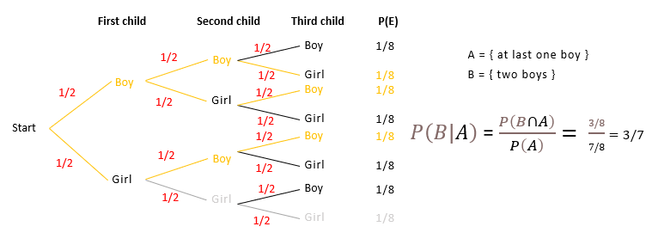

1. two boys given that the first child is a girl?

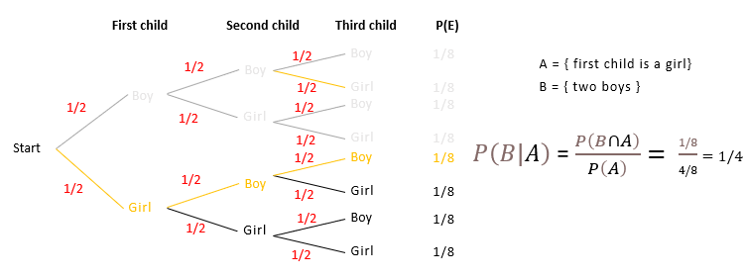

1. three girls, given that the first child is a girl?

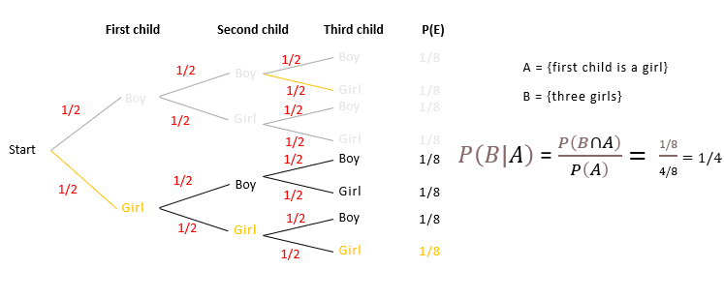

**Problem 2.4**

**Examphobia** is a rare disease in which the victim has the delusion that he or she is being subjected to an intense mathematical examination. A person selected uniformly at random has examphobia with probability 1*/*50. A person with examphobia has shaky hands with probability 7*/*10*.*A person without examphobia has shaky hands with probability 3*/*20.

What is the probability that a person selected uniformly at random has examphobia, given that he or she has shaky hands?

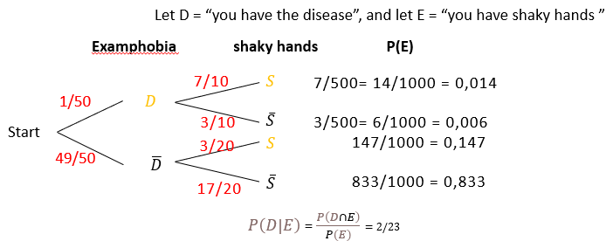

$P\left(D|E\right)$*= $\frac{P\left(D∩E\right)}{P\left(E\right)}=2/23$*

What is probability that a person doesn’t have shaky hands given that he or she has examphobia?

$$A=person doesn’t have shaky hands given that he or she has examphobia$$

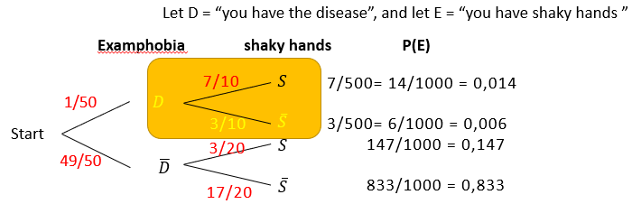 $P\left(A\right)=3/10$

**Problem 2.5**

Find the probability that in a poker hand (5 cards) you will have

1. royal flush (ten, jack, queen, king ace in one suit)
$$There are four possible suits for the ace→ Thus, there are 4 possible royal$$

$$flushes:$$

$$\begin{aligned}\# royal flushes = 4C1 = 4→ Dividing by the number of possible hands gives the probability:\end{aligned}$$

$$P(royal flush) = 4$$

$$P(a)royal flush)=\frac{4}{2598960}= 1.539 ⋅{10}^{-6}= or 1 in 649,740$$

2. straight flush (five cards in a sequence in a single suit, but no royal flush)
$$There are 9 possibilities.If we order the 5-card hand from highest number to lowest, the first card$$

$$may be one of the following: king, queen, jack, 10, 9, 8, 7, 6, or 5.$$

$$After the first card, whose suit we may choose in 4 ways, the remaining$$

$$cards are completely determined:$$

$$\# straight flushes = 9 {*C}_{1}^{4} = 9·4 = 36$$

$$Subtracting the number of royal flushes and dividing by the number of$$

$$possible hands gives the probability:$$

$$P\left(straight - flush\right)=\frac{36}{2598960}= 1.385 ⋅{10}^{-5}= or 1 in 72,193\frac{1}{3}$$

3. flush (five cards in a single suit, but not a straight or royal flush)
$$If we pick the suit first, we have C_{1}^{4}= 4 choices. For that suit, there are$$

$$13 cards from which we choose 5. Thus, we have C_{5}^{13} = 1287 choices.$$

$$\# flushes (not straight) = C_{1}^{4}·(C_{5}^{13} – 10) = 4·1277 = 5108$$

$$P(flush not straight or royal flush) =\frac{5108}{2598960}= 1.965 ⋅{10}^{-3}= or 1 in 508.8.$$

4. one pair?

$$One-pair is two cards showing the same numbers and another three cards$$

$$all showing different numbers.$$

$$a If we order the 5-card hand with the pair first, we have C_{1}^{13} choices for$$

$$the number showing on the pair. r. The pair will have two out of four suits.$$

$$Thus, we have 4C2 = 6 ways to choose the suit$$

$$\# 1-pair = C_{1}^{13}{*C}_{2}^{4}{*C}_{3}^{12}{*C}_{1}^{4}*C_{1}^{4}{*C}_{1}^{4} = 13·6·220·4·4·4 = 1,098,240$$

$$P(1- pair) =\frac{4}{2598960}= 4.226 ⋅{10}^{-1}= or 1 in 2.37$$

**Problem 2.6**

Each of the four engines of an airplane are functioning correctly on a given flight with probability of 0.99, and the engines function independently of each other. Assume that the plane can make a safe landing if at least two of its engines are functioning properly. What is the probability that the engines will allow a safe landing?

$$n = 4 \left(four engines \right) and p = 0.99→ P(2<= x <=4) = 1 - P(0<=x<=1) = 1 - 0.00000397= 0.99999603.$$

**Problem 2.7**

BONUS PROBLEM.

Two cowboys A and B decide to solve a dispute with a duel. Cowboy A hits his target 1/3 of the time. Cowboy B hits the target 2/3 of the time. It is decided that A will take the first shot, cowboy B will take the second shot (if still alive). This will continue until there is only one left alive. Also, a cowboy can not shoot two times in a row. What are cowboy A chances of winning the duel?

$$Let p be the probability that A wins. With probability 13 he wins on his first shot. With probability 23 he misses.$$

$$When B hits in his first shot, A has lost. When B misses, A again has a chance of p. It follows that$$

$$p=\frac{1}{3}+\frac{2}{3}⋅\frac{1}{3}⋅p$$

$$This implies p=\frac{3}{7}$$